

# LAB – FILE

**Graphics and Animation Tools - Lab**

**CSGG 4101**

Name – Rishank Gupta

Roll No. – R100217062

Sap id – 500062486

Course – B. Tech CSE-OSS

Batch – 2

*Under the guidance of…*

Dr.Durgansh Sharma

Associate professor

Department of Cybernetics

School of computer Science (Socs)

**Experiment- 2(a)**

**Aim: - Drawing something on paper with a pencil and then design it will GIMP.**

**Steps taken for designing the sketch**

**Step1:** Draw something on paper with a pencil.

**Step2:** Open GIMP and click on **New > Open** as layer and open the image as above.

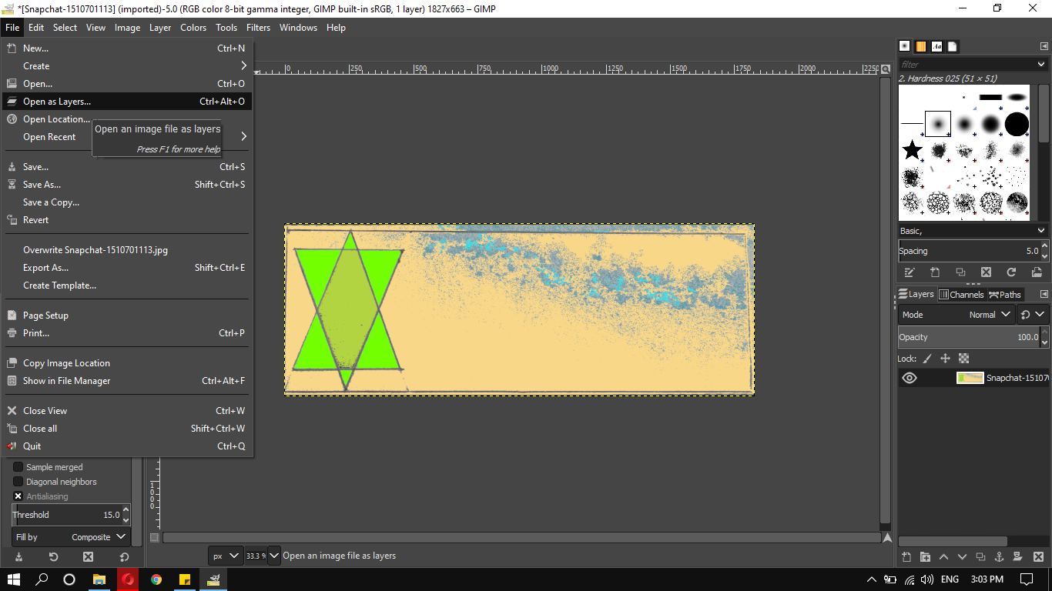

**Step3:** The image can now be edited using GIMP.

**Step4:** Export the image as **.PNG or .JPG**.

**Experiment- 2(b)**

**Aim: - Design of Logo using GIMP.**

**Steps taken for designing the logo**

**Step-1:** The very first thing what I did I just go to **file > New** and then I size the document **1280/1280 (w/h)** and in advanced option I make sure that fill with option is transparency and click OK.

**Step-2:** Now I got my new document and now I go **to Image> Guides> New guides by percent** and I select Horizontal direction and select position **50%** and click OK and did the same thing again select Vertical direction and select position **50%** and click OK.

**Step-3:** Now I go to **Ellipse** tool and draw a circle from the intersection point of vertical and horizontal guides. I make sure my default colour and background colour is white and black respectively.

**Step-4:** Now I go to **Edit> Fill with BG colour** and check the circle is filled black, go to **select>none**. Again I draw a circle smaller then before and press Delete on Keyboard to get rid of that filled area. Bring down the opacity lower. Create a new layer over that BG layer.

**Step-5:** Now I go to **Rectangular** tool and draw a rectangle from the centre slightly smaller than circle but big enough to over the edges of circle. Now I go to **Edit> Fill with BG colour** and check the rectangle is filled black, go to **select>none**. Again I draw a rectangle smaller then before and press Delete on Keyboard to get rid of that filled area. Bring down the opacity lower.

**Step-6:** Now I click on **Rotate** and rotate the rectangle at 50 and select enter. Now I create a new layer and select **Alpha to selection** then **edit> grow** at 15 px and click OK. Then go to Last layer and Fill it with BG colour and select none.

**Step-7:** Go to **colour** select red and colour it and select erase to cut that overlapping area of circle and rectangle. I leave one side and erase other side, now just select the present layer click to **alpha to selection** and then delete that layer and go back to original layer and press delete on keyboard. So the area will be deleted and **select>none**.

**Step-8:** Select the background layer and go to alpha to selection and **edit> Grow** at 15 px and click OK. Create new layer and **Fill it with BG colour** and select none.

**Step-9:** Go to colour select red and colour it and select erase to cut that overlapping area of circle. Now I just select the present layer click to alpha to selection and then delete that layer and bring the opacity **100**. Now I have the border for the **LOGO**.

**Step-10:** Select the top layer and click on **TEXT** tool and write LAB in any FONT then I simply go to MOVE tool and bring the text to centre and the I go to **alignment** tool and check vertical-horizontal alignment.

**Step-11:** click on TEXT tool and write Graphic in any FONT then I simply go to **MOVE** tool and bring the text to upper to the **LAB** and check alignment.

**Step-12:** Now I duplicate the last layer and click on **TEXT** tool and write Animation in any FONT then I simply go to **MOVE** tool and bring the text to lower to the **LAB** and check alignment.

**Step-13: LOGO** is completed and I export it as PNG file.